

**Name:** Izza Maryam **Course:** Database Systems Lab

**Sap id:** 49360 **Program:** BS CS-4

**Screenshot:**

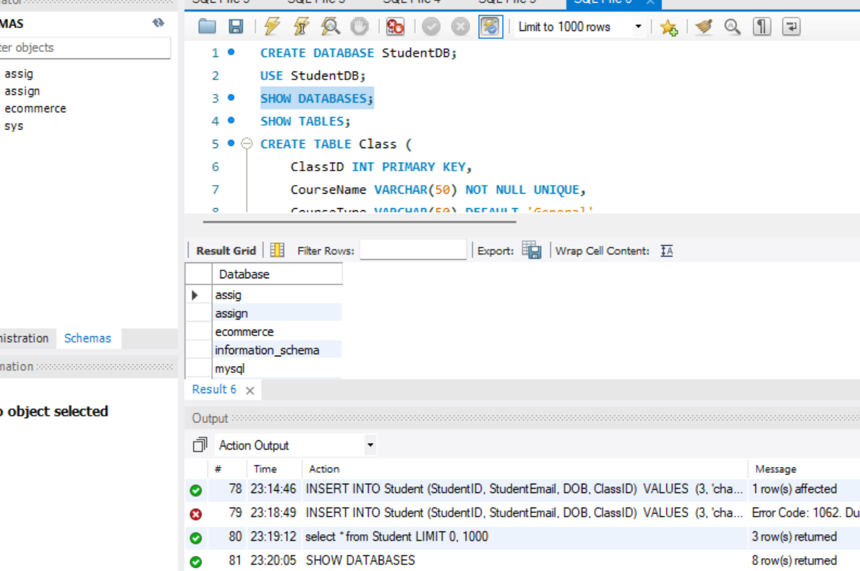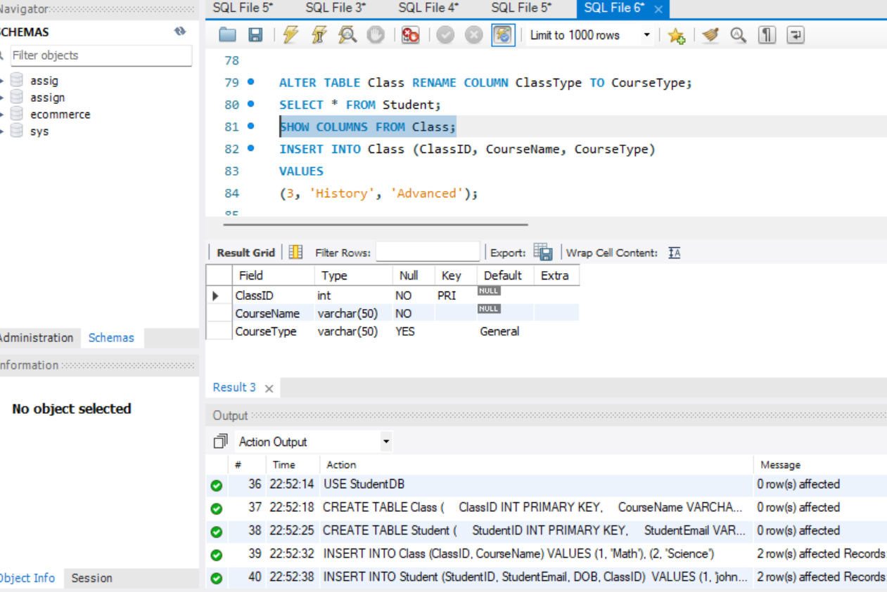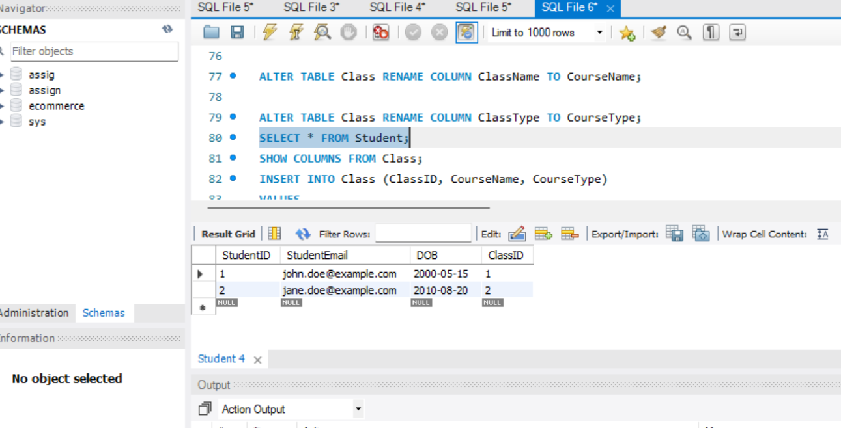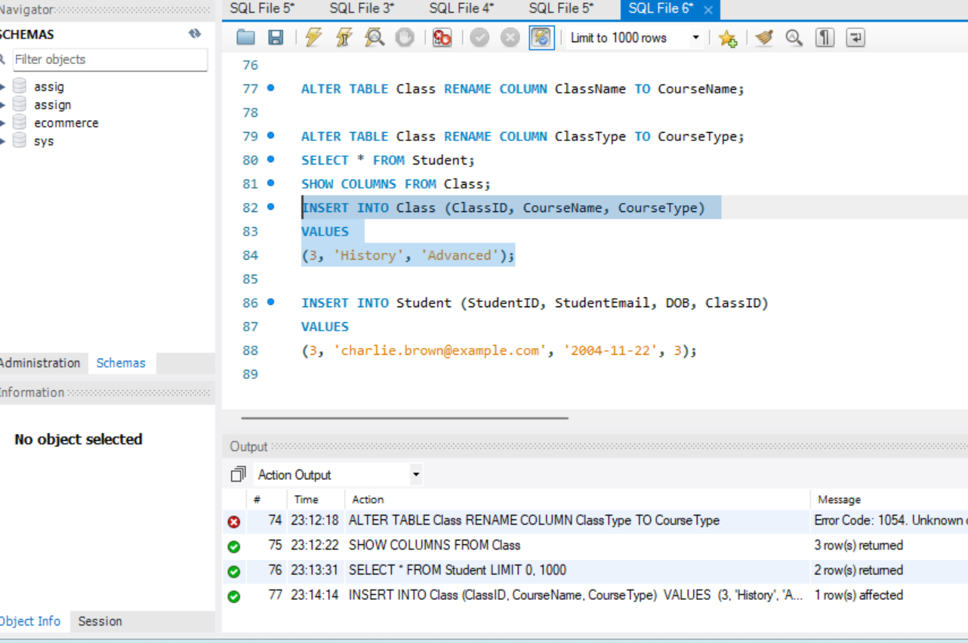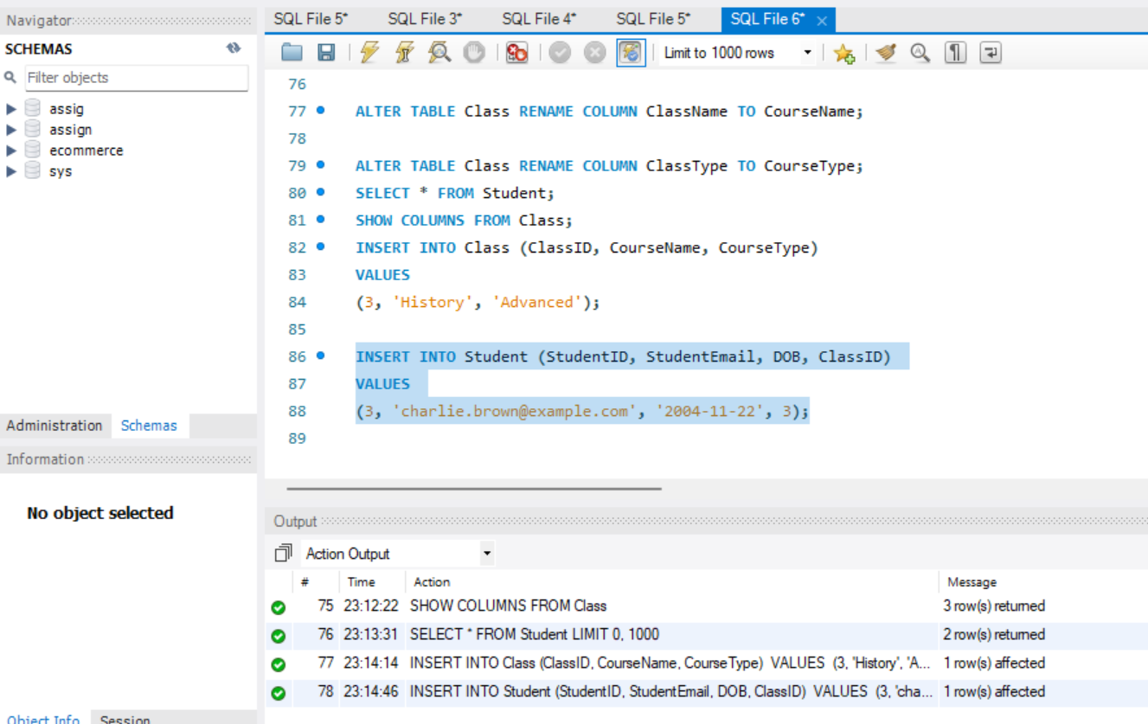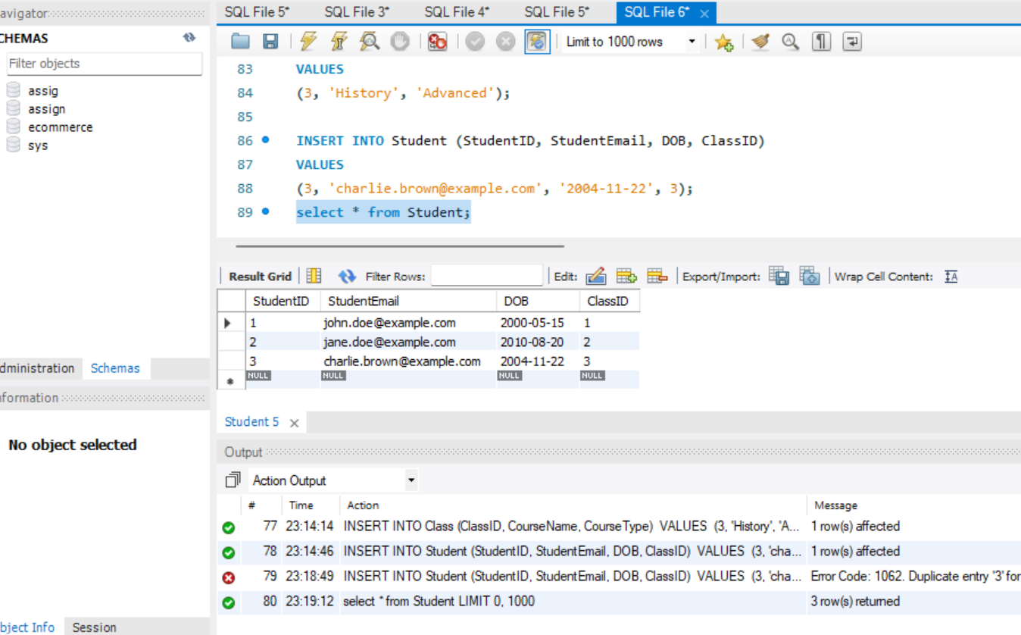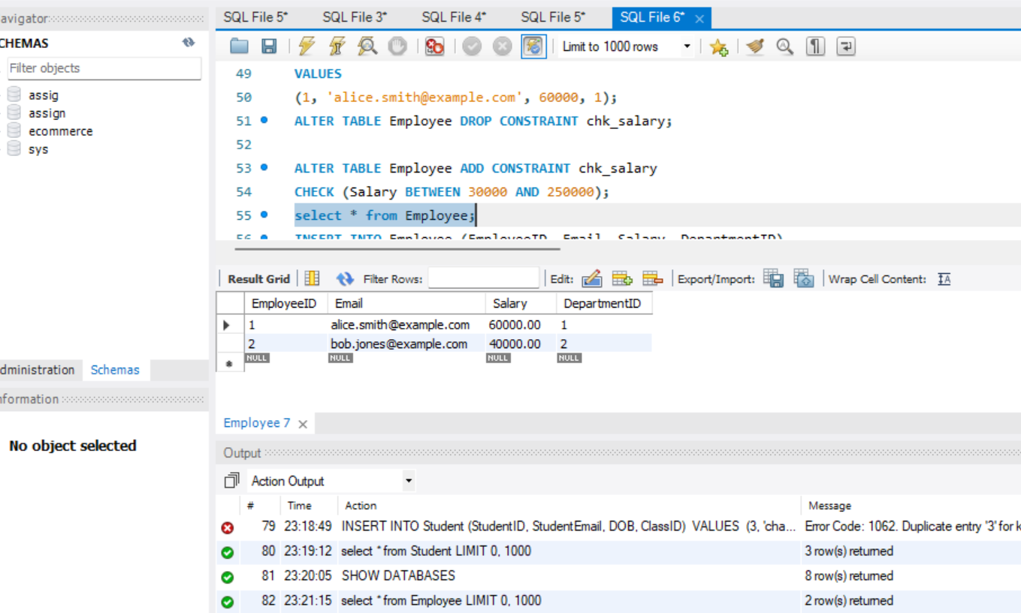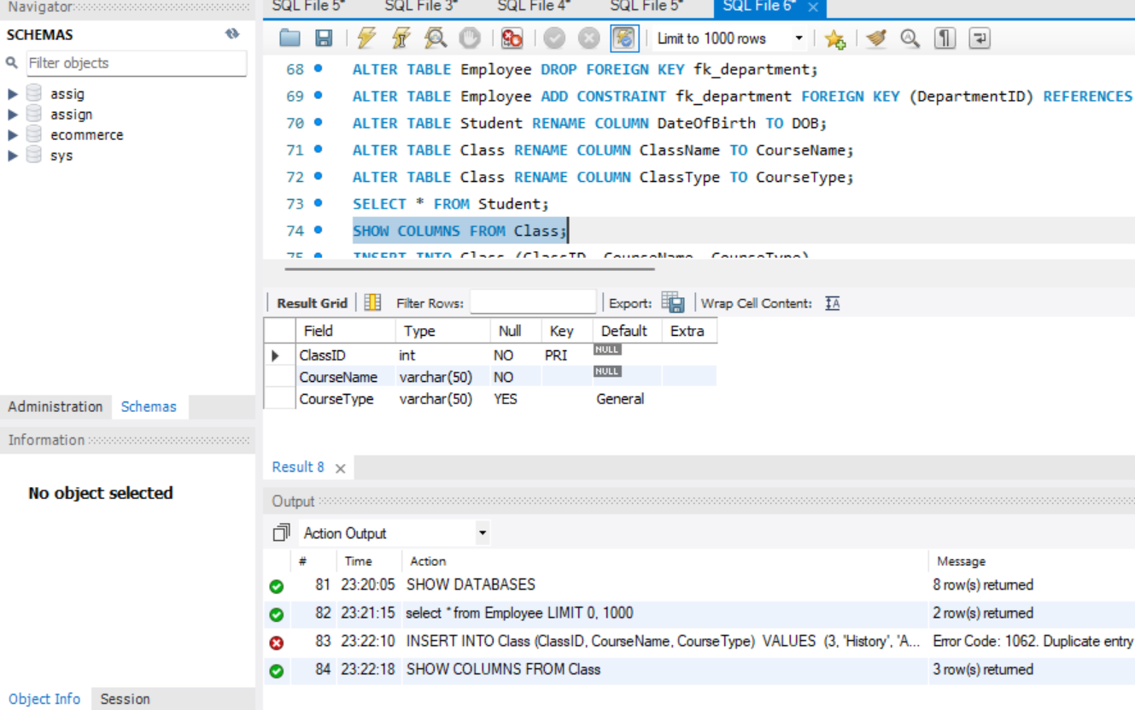

**Code:**

CREATE DATABASE StudentDB;

USE StudentDB;

SHOW DATABASES;

SHOW TABLES;

CREATE TABLE Class (

ClassID INT PRIMARY KEY,

CourseName VARCHAR(50) NOT NULL UNIQUE,

CourseType VARCHAR(50) DEFAULT 'General'

);

CREATE TABLE Student (

StudentID INT PRIMARY KEY,

StudentEmail VARCHAR(100) NOT NULL UNIQUE,

DOB DATE,

ClassID INT,

CONSTRAINT fk_class FOREIGN KEY (ClassID) REFERENCES Class(ClassID)

);

INSERT INTO Class (ClassID, CourseName)

VALUES

(1, 'Math'),

(2, 'Science');

INSERT INTO Student (StudentID, StudentEmail, DOB, ClassID)

VALUES

(1, 'john.doe@example.com', '2000-05-15', 1),

(2, 'jane.doe@example.com', '2010-08-20', 2);

ALTER TABLE Class DROP INDEX CourseName;

CREATE TABLE Department (

DepartmentID INT PRIMARY KEY,

DepartmentName VARCHAR(50) NOT NULL UNIQUE,

Location VARCHAR(100) DEFAULT 'Headquarters'

);

CREATE TABLE Employee (

EmployeeID INT PRIMARY KEY,

Email VARCHAR(100) NOT NULL UNIQUE,

Salary DECIMAL(10, 2),

DepartmentID INT,

CONSTRAINT fk_department FOREIGN KEY (DepartmentID) REFERENCES Department(DepartmentID),

CONSTRAINT chk_salary CHECK (Salary BETWEEN 50000 AND 200000)

);

INSERT INTO Department (DepartmentID, DepartmentName)

VALUES

(1, 'HR'),

(2, 'IT');

INSERT INTO Employee (EmployeeID, Email, Salary, DepartmentID)

VALUES

(1, 'alice.smith@example.com', 60000, 1);

ALTER TABLE Employee DROP CONSTRAINT chk_salary;

ALTER TABLE Employee ADD CONSTRAINT chk_salary

CHECK (Salary BETWEEN 30000 AND 250000);

select * from Employee;

INSERT INTO Employee (EmployeeID, Email, Salary, DepartmentID)

VALUES

(2, 'bob.jones@example.com', 40000, 2);

---------------------------------

SELECT CONSTRAINT_NAME

FROM INFORMATION_SCHEMA.TABLE_CONSTRAINTS

WHERE TABLE_NAME = 'Employee' AND CONSTRAINT_TYPE = 'CHECK';

ALTER TABLE Employee DROP CONSTRAINT chk_salary;

---------------------------------

ALTER TABLE Employee ADD CONSTRAINT chk_salary

CHECK (Salary BETWEEN 30000 AND 250000);

ALTER TABLE Employee ADD PRIMARY KEY (EmployeeID);

ALTER TABLE Employee DROP FOREIGN KEY fk_department;

ALTER TABLE Employee ADD CONSTRAINT fk_department FOREIGN KEY (DepartmentID) REFERENCES Department(DepartmentID);

ALTER TABLE Student RENAME COLUMN DateOfBirth TO DOB;

ALTER TABLE Class RENAME COLUMN ClassName TO CourseName;

ALTER TABLE Class RENAME COLUMN ClassType TO CourseType;

SELECT * FROM Student;

SHOW COLUMNS FROM Class;

INSERT INTO Class (ClassID, CourseName, CourseType)

VALUES

(3, 'History', 'Advanced');

INSERT INTO Student (StudentID, StudentEmail, DOB, ClassID)

VALUES

(3, 'charlie.brown@example.com', '2004-11-22', 3);

select * from Student;